# Monitoring

What do we monitor

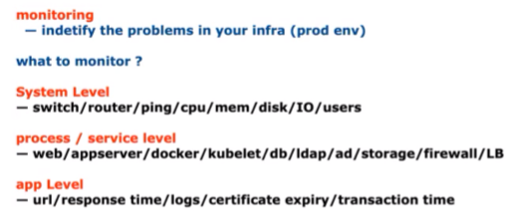

Monitoring tools available in market. We will be studying Prometheus / Grafana

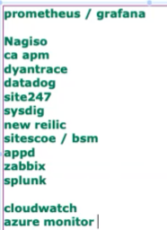

Prometheus and Grafana or Kibana are 2 different things

## Prometheus

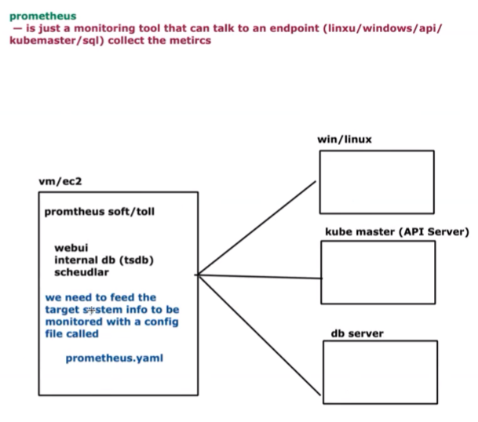

Practical. Let's deploy.

Deploy Prometheus as a kubernetes pod

<https://github.com/lerndevops/labs/blob/master/prometheus-grafana/prometheus/prometheus.yaml>

<<prometheus.yaml.txt>>

Deploy

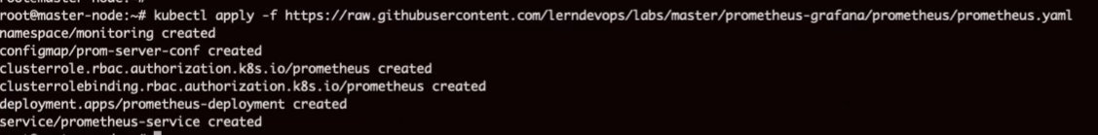

See the detail

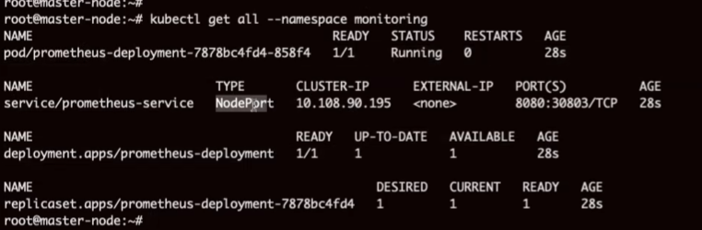

Browse

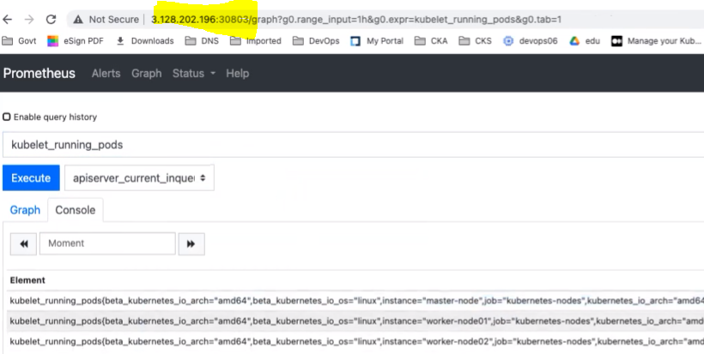

Difficult to query and read the data. It shows data in raw format.

Add some addental tool to read the data - **GRAFANA**

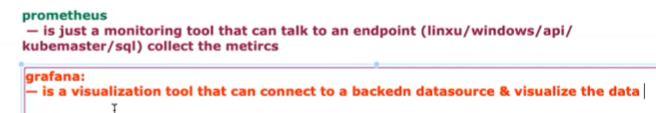

Deploye grafana

<https://github.com/lerndevops/labs/blob/master/prometheus-grafana/prometheus/grafana.yml>



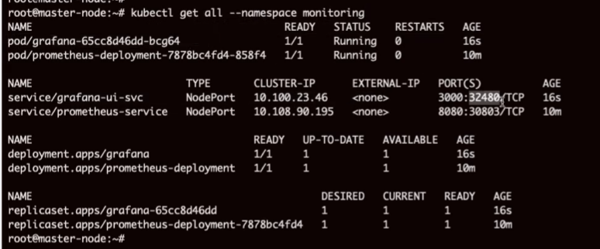

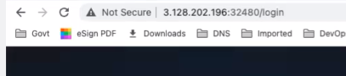

Default credential

admin

admin

Add datasource -> add data scouroce -> prometheus

It can connect to any data source in backend

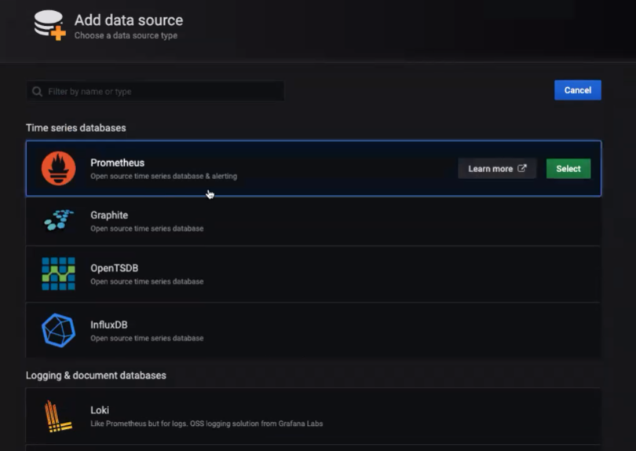

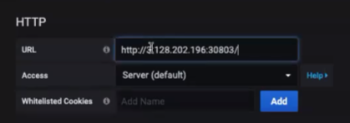

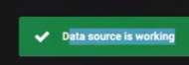

New dashboard

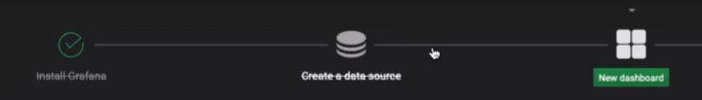

Add query

Prometheus query

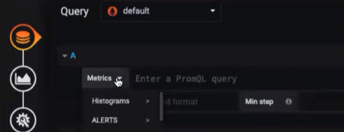

Explore the GUI

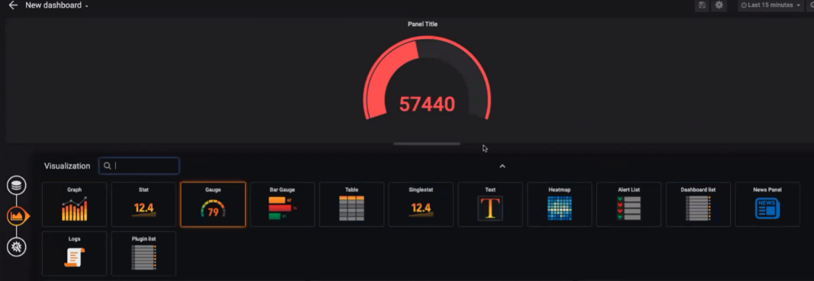

Keep on adding queries to see more

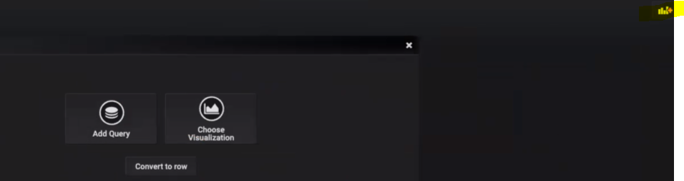

We can use readymade monitoring dashboard created in Grafana website

Gi ti unoirt

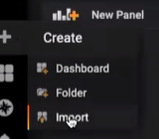

Search - Grafana kuberenetes

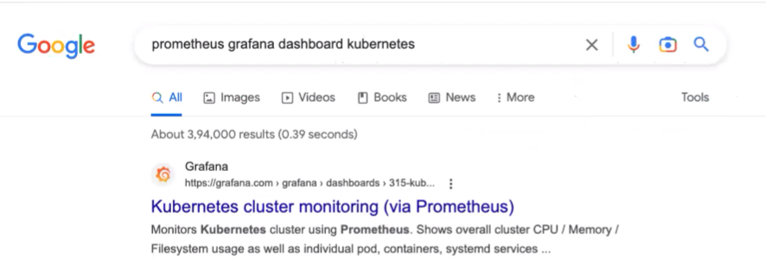

Copy the ID

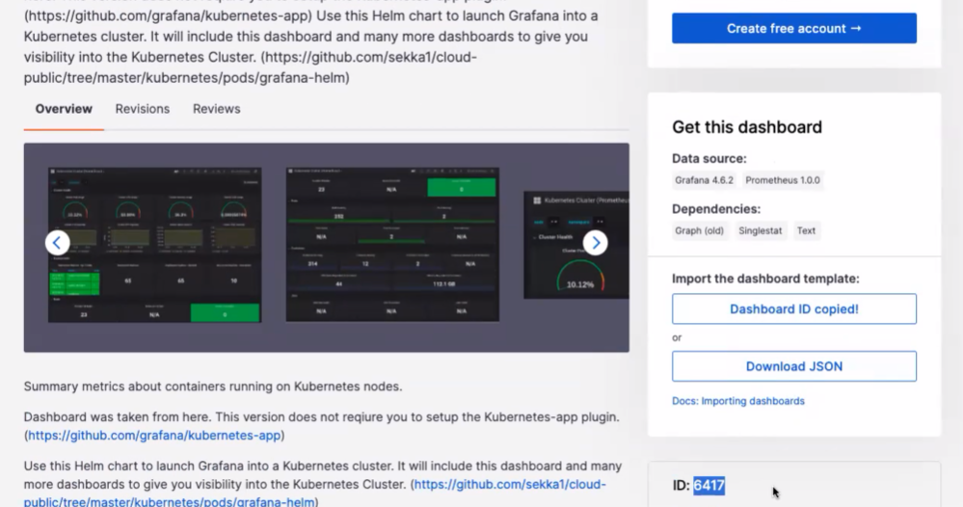

Copy the ID

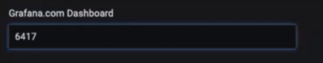

It will automatically connect to internet port. It is general monitoring

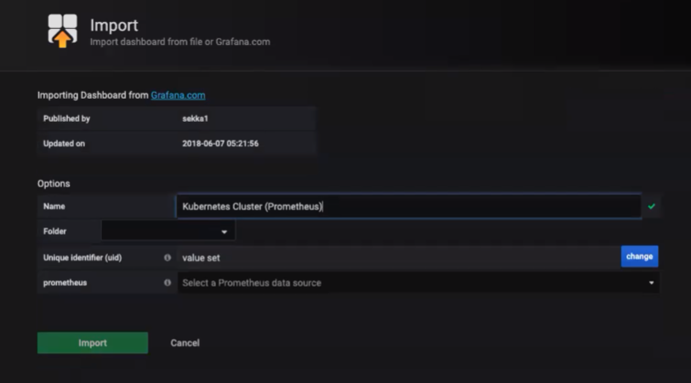

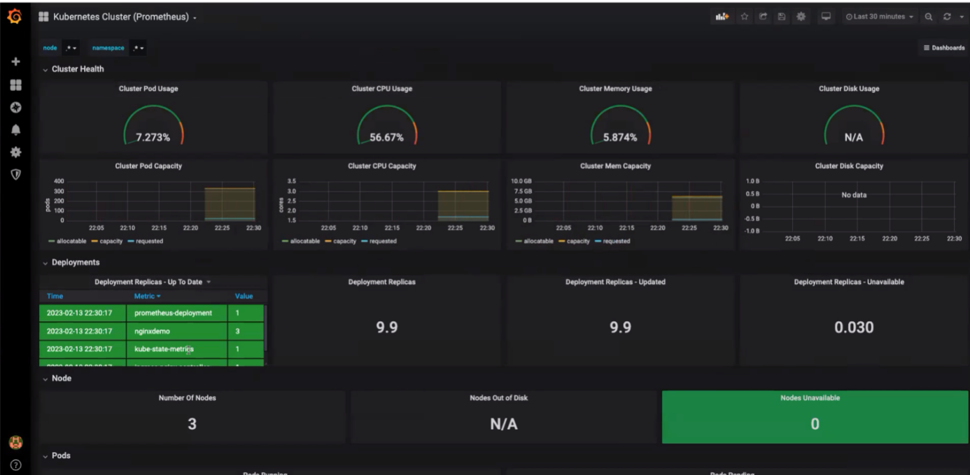

To see or edit the query, go to any section and select Edit

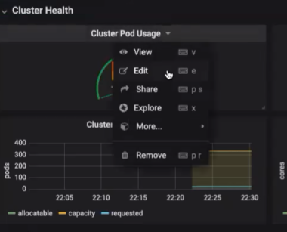

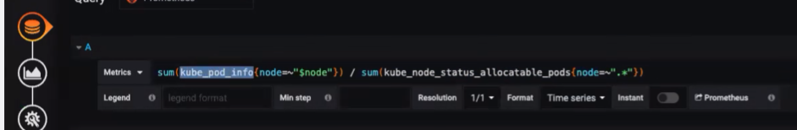

Summary:

